Current AuthoMail Monitoring System:
  - The URL https://authomail.corelogic.com/AuthoMailHealth/37f9ac3e-40b3-4ae8-ac9a-d84634638065, if shared, can be accessed anonymously. (Screenshot attached for reference.)
  - This URL can only display the Alert level, problem source (eg. In Download/In Reporting) and count of batches & mail pieces, It does not contain any sensitive information.
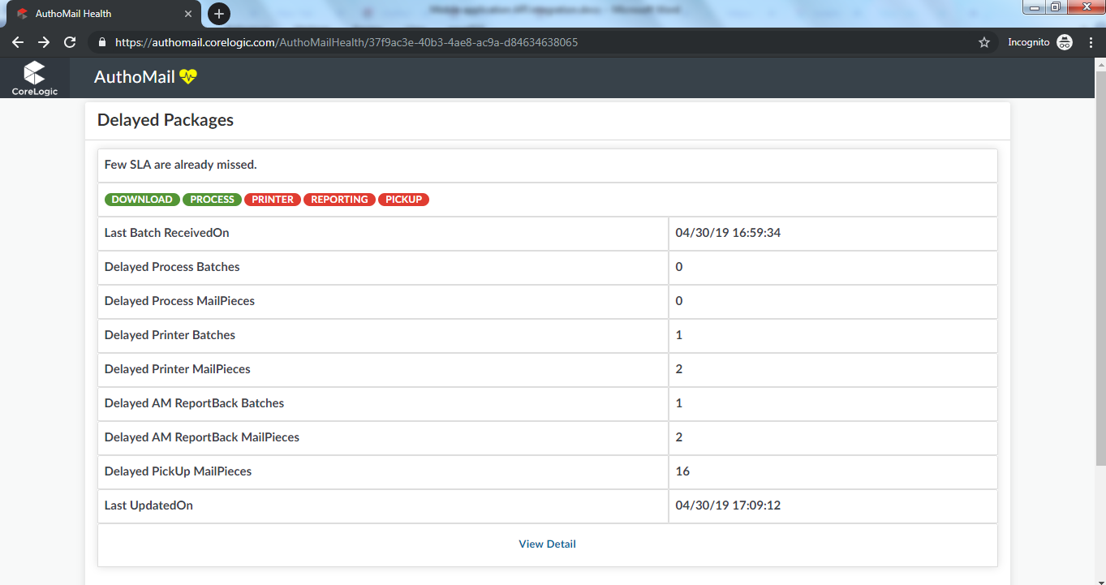
  - If user wants to see more details, they need to click on “View Detail” link, it will redirect to login page, after successful login only it will display details. (SS attached)
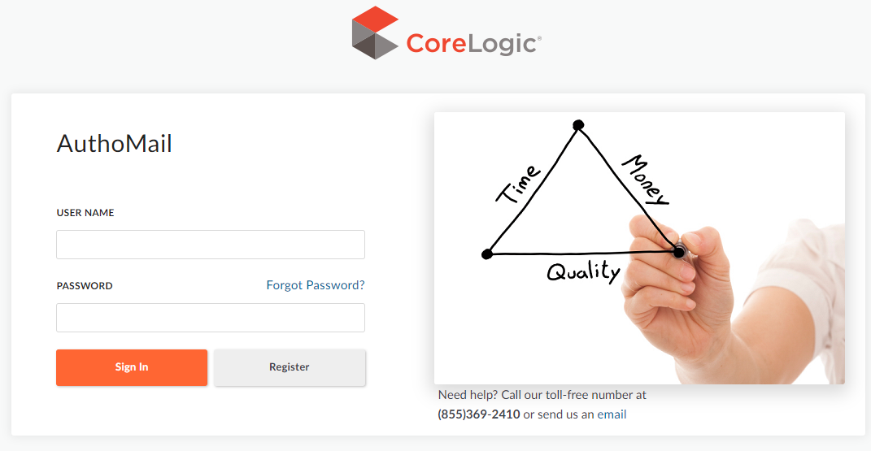
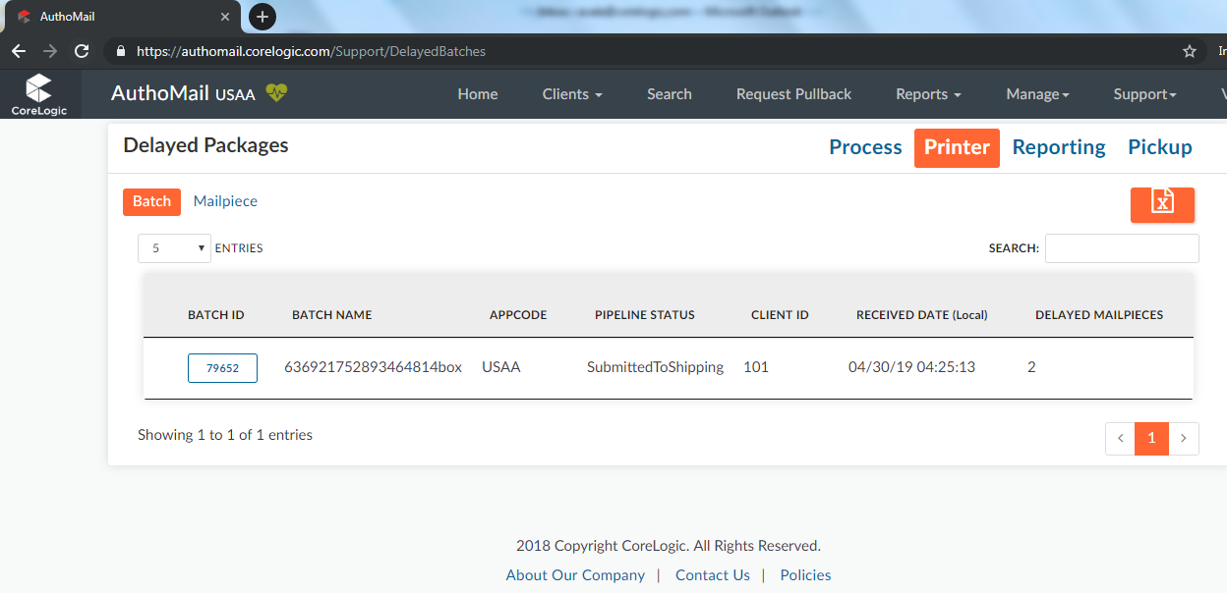

Proposed AuthoMail Monitoring System:

AuthoMail Web Server

Mobile Application

DB Server

- We can create API with anonymous access to serve the same information to mobile client.
- Another option is that we can generate API user credentials, a similar approach to USPS APIs.

